🏛️ Solution Architecture & Process Flow Diagrams
Aiam Agentic Multi-Agent Job Search & Application Platform

1. Solution Architecture Diagram & Components
The Aiam Agentic Job Search Engine features a multi-tiered architecture combining a modern Glassmorphic Frontend UI, a 5-Agent Execution Core, a Weighted 3-Tier Fitment Scoring Engine, and a Node.js SerpAPI Google Jobs Proxy Service:
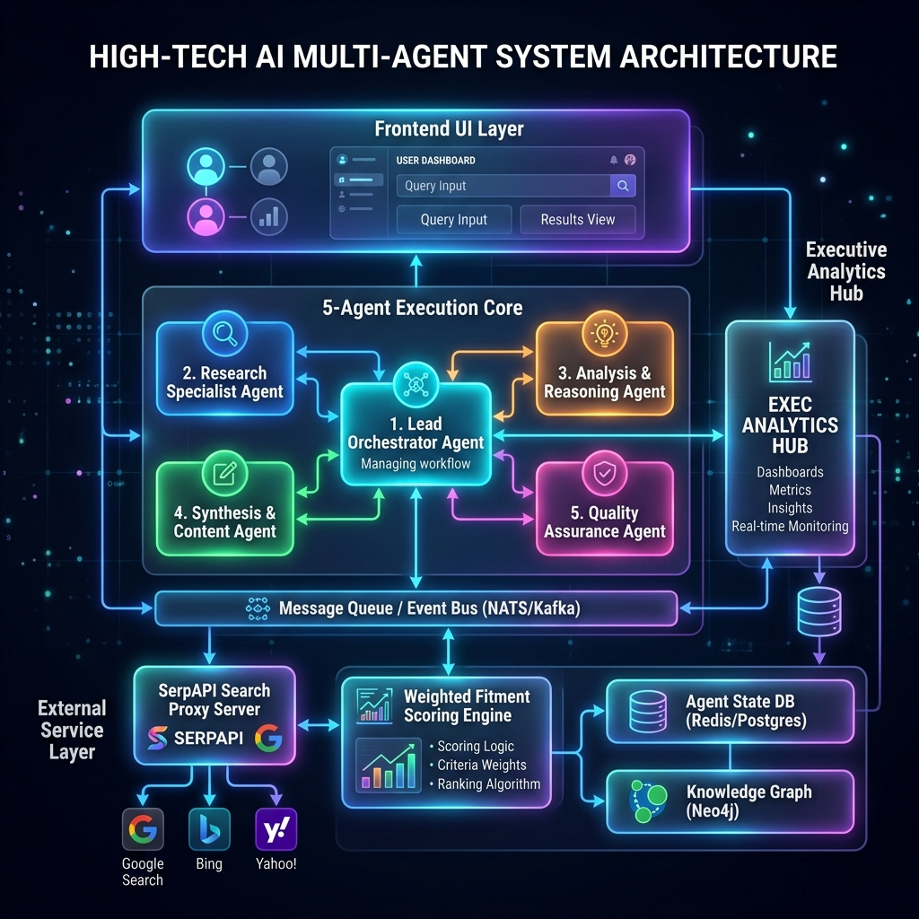
Figure 1: Solution Architecture Diagram

2. End-to-End Process Flow Diagram
The process flow diagram illustrates the sequential data transformations from Candidate Resume Intake (A1) through Job Preferences Alignment (A2), Live Search (A3), Weighted Fitment Scoring (A4), to Executive Hub Analytics (A5):
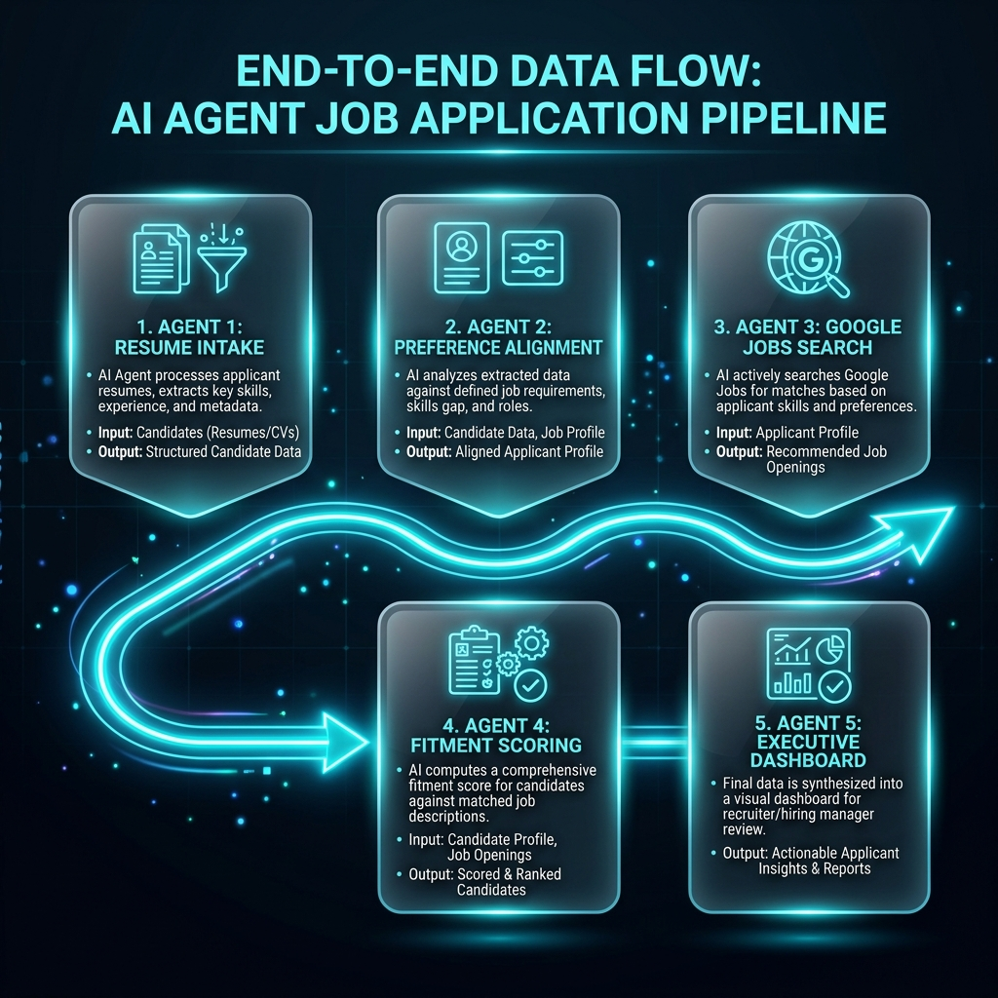
Figure 2: End-to-End Process Flow Diagram

